|  |  |
| --- | --- |
| **[Project] – External Document** |  |
| COMP8129  User Experience |
| [Odd / Even / Compact] Semester Year 2020/2021 |

* Project Title

Melodee

* Introduction

We create the Melodee app as instructed in the project case, from creating the prototype using Axure RP 9 to creating the app using Android Studio 4.

* Report / Documentation

1. Login Screen

Properties:

* Logo image using ImageView
* Slogan using TextView
* Username and Password text field using EditText
* Login button using Button
* If button pressed, the system checks the username and password. If valid, the app goes to the home screen.

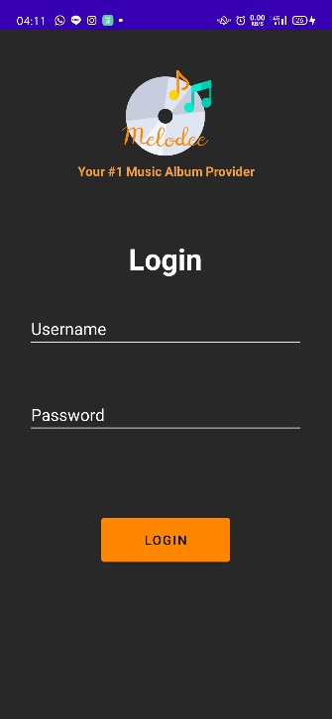

1. Home Screen

Properties:

* Home icon image using ImageView
* Welcome text using TextView and shows the inputted username
* Image carousel using ViewFlipper, contains 3 images and slides every 3 sec
* Top selling text using TextView
* Repeater for showing top selling albums using ListView. If clicked the app will show the AlbumDetail screen.
* Navbar containing 4 Buttons using ImageButton, each button will navigate to its screen.

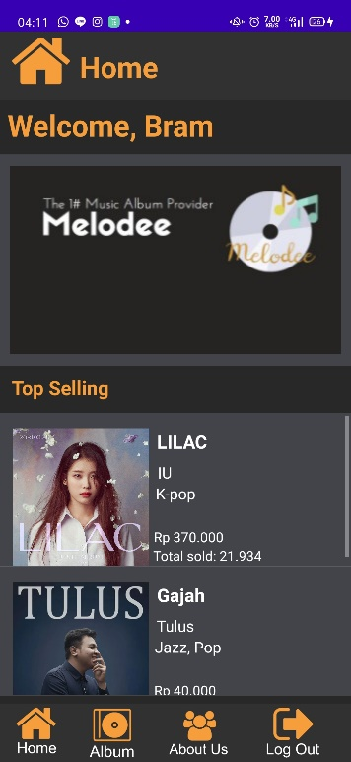

1. Album Screen

Properties:

* Album icon image using ImageView
* Album text in the header using TextView
* Repeater for showing top selling albums using ListView. If clicked the app will show the AlbumDetail screen.
* Navbar containing 4 Buttons using ImageButton, each button will navigate to its screen.

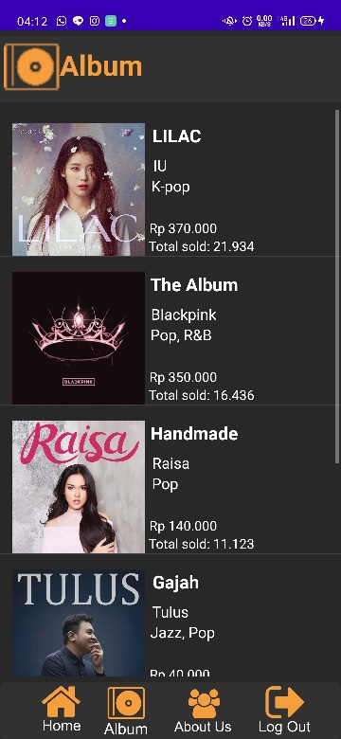

1. Album Detail Screen

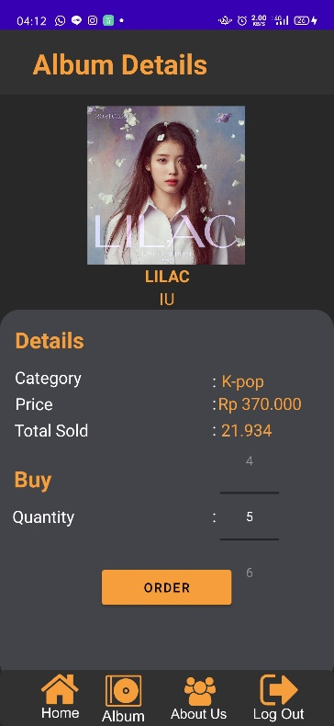

Properties:

* Album Details text in the header using TextView
* Album image using ImageView, the image depends on what user have clicked on the album list
* Album title text using TextView, the text depends on what user have clicked on the album list
* Artist name text using TextView, the text depends on what user have clicked on the album list
* Category text using TextView, the text depends on what user have clicked on the album list
* Price text using TextView, the text depends on what user have clicked on the album list
* Total sold text using TextView, the text depends on what user have clicked on the album list
* Quantity number picker using NumberPicker.
* Order button using Button, validates the quantity(if qty 0 show error)
* Navbar containing 4 Buttons using ImageButton, each button will navigate to its screen.

1. About Us – Information Screen

Properties:

* About us icon image using ImageView
* About us text in the header using TextView
* Tabs using TabLayout and ViewPager
* Information Tab shows location text and contact number text using TextView
* Navbar containing 4 Buttons using ImageButton, each button will navigate to its screen.

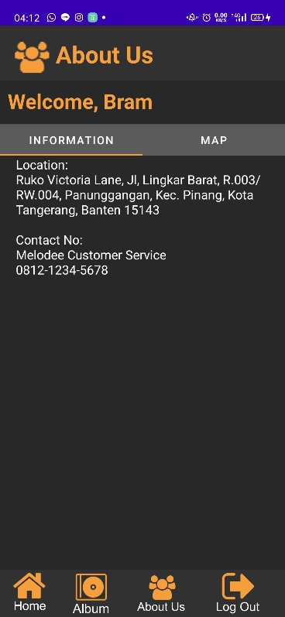

1. About Us – Map Screen

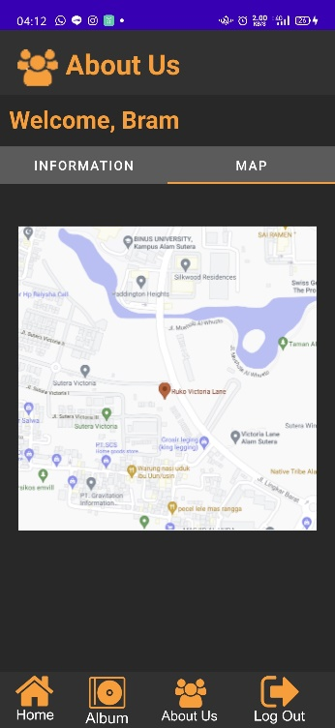

Properties:

* About us icon image using ImageView
* About us text in the header using TextView
* Tabs using TabLayout and ViewPager
* Map Tab shows the map of the location using ImageView
* Navbar containing 4 Buttons using ImageButton, each button will navigate to its screen.
* Reference
* All album images are obtained from Google
* All icon are obtained form Axure Library
* Group Member
* 2301884015 –Filipus Bramantyo Meirdivitanto
* 2301869701–Mathew Marcelino
* 2301905612– Hardyman
* 2301867513 – Velicia Natalia Wong